The Curse of Dimensionality refers to problems that happens when data has too many features or dimensions.
As the number of dimensions increases:
- Data becomes sparse (spread out).
- It gets harder to find patterns or relationships as more and more noise gets added to the data.
- Algorithms become slower and less accurate.
Why to do Dimensionality Reduction?
- To prevent Curse of Dimensionality
- Improve the performance of the models
- To help us visualize the data
Ways to remove Curse of Dimensionality
- Feature Selection
- Feature Extraction (Dimensionality Reduction)

Dimensionality Reduction
→ Reducing number of features while preserving information
4.1 Linear Dimensionality Reduction
➡️ PCA (Principal Component Analysis)
📌 PCA comes under:
Unsupervised Learning → Dimensionality Reduction → Linear Methods

4.2 Non-Linear Dimensionality Reduction
➡️ t-SNE
- Mainly used for visualization
📌 t-SNE comes under:
Unsupervised Learning → Dimensionality Reduction → Non-Linear Methods

1️⃣ PCA (Principal Component Analysis)
🔹 What it is
PCA is a linear dimensionality reduction technique that transforms data into a new coordinate system where:
- Maximum variance lies along the first axis (PC1)
- Second maximum variance along PC2, and so on
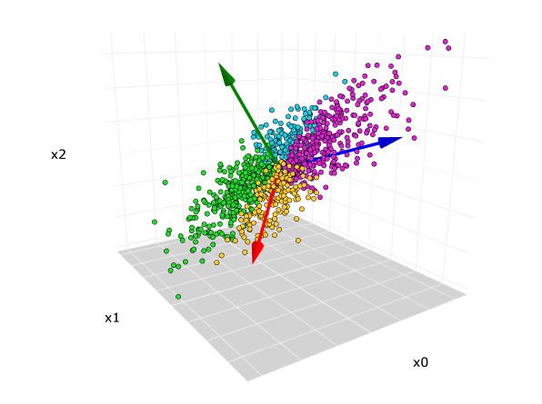
The original 3-dimensional data set. The red, blue, green arrows are the direction of the first, second, and third principal components, respectively.
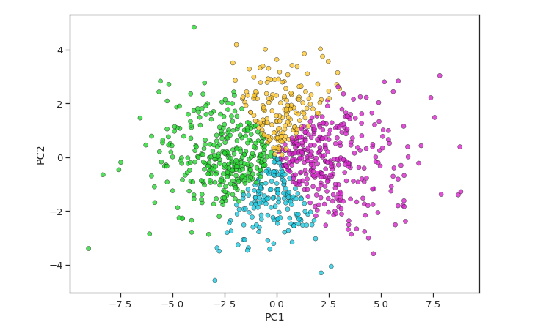
Scatterplot after PCA reduced from 3-dimensions to 2-dimensions.

🔹 How PCA works (intuition)
- Standardize the data
- Compute covariance matrix
- Find eigenvalues & eigenvectors
- Select top k eigenvectors (principal components)
- Project data onto these components

Pick the Top Directions & Transform Data
After calculating the eigenvalues and eigenvectors PCA ranks them by the amount of information they capture. We then:
- Select the top k components that capture most of the variance like 95%.
- Transform the original dataset by projecting it onto these top components.
This means we reduce the number of features (dimensions) while keeping the important patterns in the data.
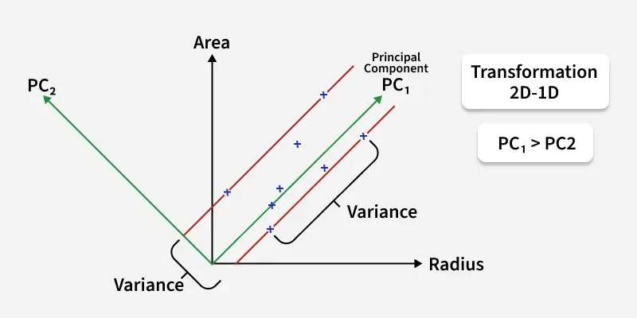

Transform this 2D dataset into a 1D representation while preserving as much variance as possible.
In the above image the original dataset has two features "Radius" and "Area" represented by the black axes. PCA identifies two new directions: PC₁ and PC₂ which are the principal components.
- These new axes are rotated versions of the original ones. PC₁ captures the maximum variance in the data meaning it holds the most information while PC₂ captures the remaining variance and is perpendicular to PC₁.
- The spread of data is much wider along PC₁ than along PC₂. This is why PC₁ is chosen for dimensionality reduction. By projecting the data points (blue crosses) onto PC₁ we effectively transform the 2D data into 1D and retain most of the important structure and patterns.

🔹 Key characteristics
Aspect | PCA
Type | Linear
Preserves | Global structure
Based on | Variance
Deterministic | Yes
Scalable | Very good

🔹 When to use PCA
✅ Noise reduction
✅ Feature compression
✅ Speeding up ML models
✅ Preprocessing before clustering (KMeans)
✅ Explaining variance in data

🔹 Example (real-world)
Customer dataset with:
- Age
- Income
- Spending Score
- Credit Limit
- Transactions
➡ PCA compresses these into 2–3 components like:
- PC1: Overall purchasing power
- PC2: Spending behavior

🔹 Output interpretation
- Explained Variance Ratio tells how much information each component retains
- Components are interpretable

GIVEN DATASET
Customer | Age | Income | CreditLimit | SpendingScore | Transactions
C1 | 25 | 20 | 30 | 80 | 120
C2 | 35 | 40 | 60 | 70 | 100
C3 | 45 | 60 | 90 | 60 | 80
C4 | 30 | 25 | 35 | 85 | 130
C5 | 50 | 80 | 120 | 40 | 60
C6 | 55 | 90 | 150 | 35 | 50
Number of samples: n = 6
Number of features: d = 5

STEP 1️⃣ Compute Mean of Each Feature
$$μ_{j}=\frac{1}{n}\sum_{i=1}^{n}{x_{ij}}$$
Feature | Mean (μ)
Age | 40
Income | 52.5
CreditLimit | 80.83
SpendingScore | 61.67
Transactions | 90

STEP 2️⃣ Compute Standard Deviation
$$σ_{j}=\sqrt{\frac{1}{n-1}∑(x_{ij}-μ_{j})^{2}}$$
Feature | Std Dev (σ)
Age | 12.25
Income | 28.17
CreditLimit | 46.37
SpendingScore | 20.41
Transactions | 31.62

STEP 3️⃣ Standardize the Dataset (Z-score)
$$z_{ij}=\frac{x_{ij}-μ_{j}}{σ_{j}}$$
Standardized Matrix $Z$
Customer | Age | Income | CreditLimit | Spending | Transactions
C1 | -1.23 | -1.15 | -1.10 | 0.90 | 0.95
C2 | -0.41 | -0.44 | -0.45 | 0.41 | 0.32
C3 | 0.41 | 0.27 | 0.20 | -0.08 | -0.32
C4 | -0.82 | -0.98 | -0.99 | 1.14 | 1.26
C5 | 0.82 | 0.98 | 0.84 | -1.06 | -0.95
C6 | 1.23 | 1.33 | 1.48 | -1.31 | -1.26
📌 Now:
- Mean = 0
- Variance = 1

STEP 4️⃣ Compute Covariance Matrix
$$Σ=\frac{1}{n-1}Z^{T}Z$$
Covariance Matrix (5×5)
$$Σ=\left[\begin{matrix}1 & 0.99 & 0.98 & -0.98 & -0.97 \\ 0.99 & 1 & 0.99 & -0.98 & -0.97 \\ 0.98 & 0.99 & 1 & -0.97 & -0.96 \\ -0.98 & -0.98 & -0.97 & 1 & 0.99 \\ -0.97 & -0.97 & -0.96 & 0.99 & 1\end{matrix}\right]$$
📌 Extremely high correlations → explains dominance of PC1.

Each value tells how strongly two variables move together:
- +1 → move together
- −1 → move opposite
- 0 → no linear relationship

Why this matters in PCA & clustering
In PCA and clustering:
🔹 In PCA:
- PCA uses this matrix to find principal components
- High correlations → PCA will compress features into fewer components
- PC1 will likely capture:
  - (+ first 3 features)
  - (− last 2 features)
That’s why PCA works very well for your data.

🔹 In clustering:
- Highly correlated features can bias distance calculations
- PCA removes redundancy before clustering

STEP 5️⃣ Eigen Decomposition
Solve:
$$∣Σ-λI∣=0$$
Eigenvalues (Variance Captured)
Component | Eigenvalue | Variance %
λ₁ | 4.93 | 98.69%
λ₂ | 0.047 | 0.93%
λ₃ | 0.012 | 0.24%
λ₄ | 0.006 | 0.12%
λ₅ | 0.005 | 0.02%
✔ Total variance = 5 (since standardized)

STEP 6️⃣ Eigenvectors (Principal Components)
PC1 Eigenvector
$$v_{1}=\left[\begin{aligned}0.445 \\ 0.450 \\ 0.448 \\ -0.446 \\ -0.447\end{aligned}\right]$$
PC2 Eigenvector
$$v_{2}=\left[\begin{aligned}0.678 \\ 0.177 \\ 0.130 \\ 0.557 \\ 0.427\end{aligned}\right]$$
📌 These are orthogonal and unit vectors.

An eigenvalue tells you how much information (variance) a principal component captures from the data.
- Large eigenvalue → very important direction in data
- Small eigenvalue → less useful direction (often noise)
📌 In PCA:
- Each principal component (PC) has one eigenvalue
- That eigenvalue = variance captured by that PC

2️⃣ What is “variance” here?
Variance = spread of data
Example:
- If points are widely spread in some direction → high variance
- If points are tightly packed → low variance
PCA looks for:
“In which direction is the data most spread out?”
That direction = PC1

3️⃣ Connection between covariance matrix & eigenvalues
You start with a covariance / correlation matrix:
$$Σ$$
Then you compute:
$$Σv=λv$$
Where:
- $v$= eigenvector → direction
- $λ$= eigenvalue → how much variance in that direction
👉 So:
- Eigenvector = direction of maximum spread
- Eigenvalue = amount of spread

- Example data: Income, Credit Limit, Spending Score
- Income and Credit Limit increase together
- Spending Score decreases as Income increases
- Data spreads mostly along one diagonal direction
- PCA finds this direction as PC1
- PC1 has a large eigenvalue → captures most variance (main information)
- Other directions have very little spread
- Their eigenvalues are small → minor variation or noise
- Eigenvalue = amount of information (variance) captured by a PC

STEP 7️⃣ Principal Component Equations
🔹 PC1
$$\text{PC1}=0.445(\text{Age})+0.450(\text{Income})+0.448(\text{CreditLimit})-0.446(\text{SpendingScore})-0.447(\text{Transactions})$$
🔹 PC2
$$\text{PC2}=0.678(\text{Age})+0.177(\text{Income})+0.130(\text{CreditLimit})+0.557(\text{SpendingScore})+0.427(\text{Transactions})$$

STEP 8️⃣ Projection (Dimensionality Reduction)
$$Y=Z⋅V$$
What is this?
$$\boxed{Y=Z⋅V}$$
This is just matrix multiplication, and it means:
Project the standardized data onto the principal component directions
Let’s break each symbol down slowly.

1️⃣ What is Z?
Z = standardized data matrix
From earlier steps, after standardization:
- Rows = customers
- Columns = features
So Z has shape:
$$Z∈R^{6×5}$$
Example (simplified):
$$Z=\left[\begin{matrix}-1.23 & -1.15 & -1.10 & 0.90 & 0.95 \\ -0.41 & -0.44 & -0.45 & 0.41 & 0.32 \\ ⋮ & ⋮ & ⋮ & ⋮ & ⋮\end{matrix}\right]$$
Each row = one customer in standardized feature space

2️⃣ What is V?
V = matrix of eigenvectors (principal components)
You selected 2 PCs, so:
$$V=\left[\begin{matrix}0.445 & 0.678 \\ 0.450 & 0.177 \\ 0.448 & 0.130 \\ -0.446 & 0.557 \\ -0.447 & 0.427\end{matrix}\right]$$
Shape:
$$V∈R^{5×2}$$
- Column 1 → PC1 direction
- Column 2 → PC2 direction

3️⃣ What is Y?
Y = PCA scores (projected data)
After multiplication:
$$Y∈R^{6×2}$$
This is your final reduced dataset:
Customer | PC1 | PC2
C1 | -2.10 | 1.80
C2 | -0.90 | 0.90
C3 | 0.20 | -0.10
C4 | -1.80 | 2.00
C5 | 1.70 | -1.50
C6 | 2.90 | -2.10

4️⃣ What does the multiplication actually DO?
For one customer, say C1:
$${\text{PC1}}_{C1}=(-1.23)(0.445)+(-1.15)(0.450)+(-1.10)(0.448)+(0.90)(-0.446)+(0.95)(-0.447)$$
That sum = −2.10
➡ This is just a weighted sum.
📌 So:
Each PC score =
(standardized features × PC weights)

Final PCA Scores
Customer | PC1 | PC2
C1 | -2.10 | 1.80
C2 | -0.90 | 0.90
C3 | 0.20 | -0.10
C4 | -1.80 | 2.00
C5 | 1.70 | -1.50
C6 | 2.90 | -2.10

STEP 9️⃣ Final Reduced Representation
Original:
R⁵ → [Age, Income, CreditLimit, SpendingScore, Transactions]
Reduced:
R² → [PC1, PC2]

🎯 Final Interpretation (Mathematically Correct)
- PC1 (~99%): Dominant financial–behavior axis
- PC2 (<1%): Minor residual variation
- Dataset is effectively 1-dimensional

Explained Variance Ratio: [0.98687771 0.00934605]
This means:

Component | Variance Explained
PC1 | 98.6878%
PC2 | 0.9346%

Explained Variance Ratio — what it tells you:
- It shows how much of the total data variance is explained by each principal component
- It is eigenvalue ÷ sum of all eigenvalues
- Values are between 0 and 1 (or 0%–100%)
- High value → component is very important
- Low value → component adds little information
- Cumulative explained variance tells how many PCs to keep
- Example:
  - PC1 = 0.72 → explains 72% of data
  - PC2 = 0.18 → explains 18%
  - PC1 + PC2 = 90% → enough for dimensionality reduction
- Used to decide optimal number of components in PCA

2️⃣ t-SNE (t-Distributed Stochastic Neighbor Embedding)
🔹 What it is
t-SNE is a non-linear technique mainly used for visualization of high-dimensional data in 2D or 3D.

Term | Meaning
t-Distributed | Uses t-distribution to avoid crowding
Stochastic | Probability-based and random
Neighbor | Preserves local similarities
Embedding | Maps data to low-dimensional space

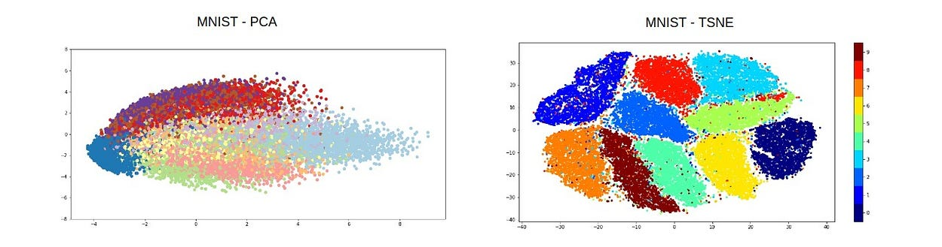
🔹 How t-SNE works (intuition)
- Converts distances between points into probabilities
- Preserves local neighborhoods
- Tries to keep similar points close together

🔹 Key characteristics
Aspect | t-SNE
Type | Non-linear
Preserves | Local structure
Based on | Probability similarity
Deterministic | ❌ No (random init)
Scalable | Poor for large data

🔹 When to use t-SNE
✅ Visualizing clusters
✅ Understanding embeddings (NLP, CNN features)
✅ Exploring high-dimensional data
❌ Not for feature reduction in production

🔹 Example (real-world)
Word embeddings (300 dimensions)
➡ t-SNE projects them into 2D so similar words cluster together visually

MAJOR PARAMETERS
1️⃣ n_components=2
What it means
- Number of dimensions in output
- 2 → 2D plot
- 3 → 3D plot
Why we use 2
- For visualization
- Human-readable plots
📌 Rule:
t-SNE is mainly for visualization, not modeling.

2️⃣ perplexity=30 ⭐ (MOST IMPORTANT)
What is perplexity?
Perplexity ≈ number of nearest neighbors considered
📌 Think of it as:
“How many nearby points should each point care about?”

Low vs High Perplexity
Perplexity | Behavior
5–10 | Very local structure (small tight clusters)
20–50 | Balanced (recommended)
>50 | More global structure, clusters may merge
Why 30 is commonly used
- Works well for medium-sized datasets
- Balances local + global structure
📌 Rule of thumb:
perplexity < number_of_samples / 3

3️⃣ learning_rate=200
What it means
- Step size during optimization
- Controls how fast points move in the embedding
Low vs High Learning Rate
Learning Rate | Effect
Too low (<10) | Points collapse into one blob
Too high (>1000) | Scatter unstable, random
100–300 | Stable and common
📌 Why 200 works well
- Default range suggested by sklearn
- Good convergence for most datasets

Why Silhouette Score is Important
- Measures Cluster Quality:
  - It evaluates how well each data point fits into its assigned cluster.
  - Formula conceptually:
$$s=\frac{b-a}{max⁡(a,b)}$$
where:
    - $a$= average distance to points in the same cluster (cohesion)
    - $b$= average distance to points in the nearest different cluster (separation)
- Range & Interpretation:
  - Values range from -1 to 1:
    - +1 → perfectly clustered, well separated
    - 0 → on or very close to the cluster boundary
    - -1 → misclassified, likely in the wrong cluster
- Helps Choose the Number of Clusters:
  - You can calculate silhouette scores for different k values in k-means or other clustering algorithms to see which k gives the best separation.

Algorithm | How to use silhouette score
K-Means | Compute for different k → choose k with max score
Agglomerative | Compute for different n_clusters → choose max score
DBSCAN | Compute for different eps/min_samples → choose params with max score; ignore noise points

